Technical Note v 3.0 _ Gowns, caps, overshoes and shoes of 4 April 2020

GENERAL DESCRIPTION
Gowns, caps, overshoes and shoes for hospital/healthcare use are protective clothing against infectious agents and are classified as III ^ category Personal Protective Equipment (PPE) according to EU Regulation 2016/425 for which the procedures for the acquisition of the CE marking shall apply.
Clothes worn by surgical teams or surgical drapes laid over patients to prevent cross-contamination during surgery are not dealt with within the purpose and scope of this Technical Note.

Applicable Standards
The reference standards for this type of clothing are UNI EN 14126: 2004 and UNI EN ISO 13688: 2013.
UNI EN 14126: 2004 specifies the requirements and test methods for reusable and limited-use (disposable) protective clothing that provide protection against infectious agents. Minimum required performance level: Type PB 6-B (potential exposure to light splashes, low pressure liquid aerosols and small splashes)
UNI EN ISO 13688: 2013 specifies the general requirements applicable to protective clothing (ergonomics, sizes, harmlessness of materials).

Responsible entities
The entities responsible for CE certification are the Notified Bodies pursuant to EU Regulation 2016/425 and specifically authorized for protective clothing against biological agents.
In the Covid-19 emergency phase, the extraordinary validation in derogation of PPE is entrusted to INAIL.
In this emergency phase, and only until this emergency persists, production and marketing authorization is granted in derogation of the current legislation, pursuant to Law Decree of 17 March 2020 no. 18 art. 15, according to a simplified procedure.
As of today, this exemption authorization is granted until 31 July 2020.
Companies requesting authorization in derogation with a simplified procedure can subsequently complete the CE certification process in order to market the PPE after this date.

Certification procedure
Two procedures can be followed:
- standard procedure (CE marking): allows obtaining permanent authorization for the production of Class III PPE according to current legislation;

(duration of the CE certification procedure: 5 days from the receipt of samples)
- procedure in derogation: allows obtaining the temporary concession for the production of class III PPE medical devices in derogation from current legislation;
(duration of the derogation procedure: 2-4 days)

Standard procedure
EN 14126 standard requires the following tests.
Tests on fabrics
• abrasion (UNI EN 530: 2010 Met. 2 + UNI EN 14325: 2005 Par. 4.4.1 + UNI EN 14126: 2004 Par. 4.1.2
• trapezoid-method laceration (UNI EN ISO 9073-4: 1999 + UNI EN 14325: 2005 Par. 4.7 + UNI EN 14126: 2004 Par. 4.1.2)
• resistance to damage by flexing (UNI EN ISO 7854: 1999 Met. B + UNI EN 14325: 2005 Par. 4.5 + UNI EN 14126: 2004 Par. 4.1.2)
• traction (strip method) - UNI EN ISO 13934-1: 2013 + UNI EN 14325: 2005 Par. 4.9 + UNI EN 14126: 2004 Par. 4.1.2
• perforation (UNI EN 863: 1997 + UNI EN 14325: 2005 Par. 4.10 + UNI EN 14126: 2004 Par. 4.1.2)
• penetration of blood and body fluids. Synthetic blood method (ISO 16603: 2004 + UNI EN 14126: 2004 Par. 4.1.4.1)
- penetration of pathogens carried by blood and other body fluids. Bacteriophage method Phi-X174 (ISO 16604: 2004 + UNI EN 14126: 2004 Par. 4.1.4.1)
- wet bacterial penetration (UNI EN ISO 22610: 2006 + UNI EN 14126: 2004 Par. 4.1.4.2)
- penetration of biologically contaminated liquid aerosols (ISO / DIS 22611: 2003 + UNI EN 14126: 2004 Par. 4.1.4.3)
- penetration of biologically contaminated dust (UNI EN ISO 22612: 2005 + EC 1-2011 + UNI EN 14126: 2004 Par. 4.1.4.4)
- ph (UNI EN ISO 3071: 2006 + UNI EN ISO 13688: 2013 Par. 4.2)
- amines (UNI EN ISO 14362-1: 2017 + UNI EN ISO 13688: 2013 Par. 4.2)
Tests on clothes
- size
- check of ergonomics
- check of specific design requirements
- seam tensile properties (Grab method) - UNI EN ISO 13935-2: 2014 + UNI EN 14325: 2005 Par. 5.5 + UNI EN 14126: 2004 Par. 4.1.2
The tests according to EN 14126 will be carried out again if the gown is disposable; if it is reusable the tests must be carried out after the maximum number of washes indicated on the label (min. 5 washing cycles) and, in addition, size changes must be made on the fabric (in this case the time needed for the washing cycles is to be added).

Procedure in derogation (only if disposable)
Considering the tests included in the certification, the derogation procedure exclusively provides for the following tests, considered as significant and selective by INAIL.
Tests on fabrics
- penetration of blood and body fluids. Synthetic blood method (ISO 16603: 2004 + UNI EN 14126: 2004 Par. 4.1.4.1).
- viral penetration test ISO 16604 at the maximum pressure supported by the fabric.

The fabric testing procedure consists of the performance of the two tests indicated above. The ISO 16604 viral penetration test is only performed on fabric samples that have passed the ISO 16603 synthetic blood penetration test.
The tests are carried out by applying 20kPa of pressure (value provided for by ISO 16604 standard for class 6, or the most performing class of fabrics, see table 1) and the fabric shall be deemed suitable only if it passes this viral penetration test at 20kPa.

Class | Hydrostatic pressure at which the fabric passes the test
6 | 20 kPa
5 | 14 kPa
4 | 7 kPa
3 | 3.5 kPa
2 | 1.75 kPa
1 | 0 kPaa)
a) This means that the material is exposed only to the hydrostatic pressure of the liquid in the test cell.

Table 1: Classification of resistance to penetration of contaminating liquids under hydrostatic pressure (ISO/FDIS 16604).

Tests on clothes

- size
- check of ergonomics
- check of specific design requirements
- seam tensile properties (Grab method) - UNI EN ISO 13935-2: 2014 + UNI EN 14325: 2005 Par. 5.5 + UNI EN 14126: 2004 Par. 4.1.2
Clothes can be one-size or multi-size (at least S, M, L, XL),

Where to carry out tests
The tests required by law to obtain CE certification for the production (standard procedure) of protective clothing (gowns, caps and shoes) can be carried out by an Authorized Notified Body for the CE certification of protective clothing against biological hazards.
Centro Tessile Cotoniero e Abbigliamento S.p.A (CENTROCOT) of Busto Arsizio (VARESE) is a Notified Body with a specific textile microbiology laboratory.

The tests to obtain the certificate for the production in derogation (procedure in derogation) of protective clothing (gowns, caps and shoes) from INAIL must be carried out exclusively at the Centro Tessile Cotoniero e Abbigliamento S.p.A (CENTROCOT).

Gowns, caps, shoe overshoes, shoes and the fabric samples (in the number and sizes specified below) must be sent to CENTROCOT with the indication of the procedure to be followed (STANDARD or IN DEROGATION).
Gowns, caps, the overshoes, shoes and the fabric samples (as specified below) must be sent to:
Centro Tessile Cotoniero e Abbigliamento S.p.A Piazza S.Anna, 2 · 21052 Busto Arsizio (VA)

Contact person for sample delivery Dr. Gianni Tanchis, Head of Biology Laboratory - tel. 0331-696721 - 0331-696740

Samples needed for the standard procedure
Complete clothing:
- one size: 3 clothes
- multi-size: 3 clothes (S, M, XL)
Fabric:
3mt full height

Samples needed for the procedure in derogation
Complete clothing:
- one size: 3 clothes
- multi-size: 3 clothes (S, M, XL)
Fabric:
0.5 mt full height

CENTROCOT contact persons:

Marco Colli, Head of Personal Protective Equipment Area and related laboratories; marco.colli@centrocot.it, mob. +39 348 311.3841

Elisabetta Castelli, Head of Certification Scheme; (contact person for standard procedure) elisabetta.castelli@centrocot.it

Gianni Tanchis, Head of Biology Laboratory; (contact person for procedure in derogation and sample delivery)
gianni.tanchis@centrocot.it tel. +39 0331 6769721 - +39 0331 6769740

Indications on materials
In general, III category PPEs (gowns, caps and shoes) are typically made up of 1 or more layers of non-woven fabric (TNT) in polypropylene manufactured with SPUNLACE or SPUNBOND technology coupled with barrier film of Ethylene Vinyl Acetate (EVA) or Polyethylene.
To date, the manufacturers of materials suitable to produce PPE in compliance with UNI EN 14126 according to standard procedure are reported in table 2.

MANUFACTURER | PRODUCT | CERTIFICATE no./ TEST REPORT
Tessiture PIETRO RADICI | S7000050020LAM DYLAR PP SPUNB LAM | CO0537200024-00-00

Table 2: List of materials suitable for manufacturing individual protective clothing.

To date, the manufacturing companies whose fabrics are in the testing phase to be certified as suitable according to the procedure in derogation are shown in table 3.

MANUFACTURER | FABRIC
ATEX
F.LLI TOIA | MAGIC art. MS24BSB (PP/LDPE/PP structure)
INDUTEX PUNTIFORM
KERING
NT MAJOCCHI
WINTEX

Table 3: List of suitable materials according to procedures in derogation.

General indications:

Clothing can be manufactured in one size or in different sizes.
As for gowns, they must have a rear closure with a tie fastening on neck and a waist belt.

Example of production cycle of one-size gowns

GOWN (one item)
Gown with one body and two sleeves.
Body
One-piece body, rectangle-shaped, properly shaped at the neck, at the armhole and at the shoulders. The shoulders are assembled by sewing. Back overlap closure with belt and neck strap.
The upper edge of the gown is finished with a edge of about 1 cm high, left free at the ends (total edge length about of 150 cm); the ends of the edge are left free to allow the user to fasten the gown by "knotting" around the neck. This edge is obtained by folding on itself a section of the same material as the one used to manufacture the body.
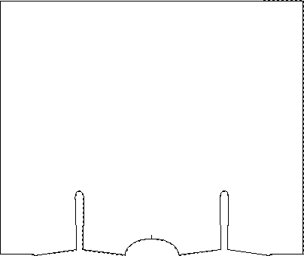

Fig. 1: Body of the gown. Size: cm 142x119 approx.

Sleeves

Sleeves made of a single trapezoid-shaped piece closed on itself to form a cone assembled by sewing made on the top, along the seam on the shoulders. Each sleeve is assembled to the body by sewing and is finished with a 7 mm high band applied to the bottom, along the free side (approximate circumference of the bottom of the sleeves with band not under tension: 18 cm).

Fig. 2: Sleeves. Size: larger base 59 cm; h 63 cm; smaller base 33.5 cm approx.

A further edge, approx. 158 cm long and with the same characteristics as the one indicated above, is applied to the left side by sewing approximately 4 cm long, made at approximately 23 cm from the base of the armholes to allow the user to fasten the gown through " knotting ”around the waist.

SIZE OF FINISHED CLOTHING | cm
Sleeve length | 64
Total length in the front centre | 112
Half chest measured on the front | 67

CAP (1 item)
Cap made of a single piece, circle-shaped, equipped with a "headband" approximately 7 mm high assembled by sewing along the free perimeter (approximate circumference with band not under tension: 44 cm).

Fig. 3: Cap. Size: Ø cm 48 approx.

OVERSHOES (2 items)
Shoe made of a single piece, rectangle-shapes. This rectangle is folded on itself thus obtaining a "sack" approximately 13.5 cm high fixed at the ends. Each shoe is finished with a 7 mm high band assembled by sewing along the free side (approximate circumference with band not under tension: 36 cm).

Fig. 4: Shoes. Size: cm 40x27 approx.

SHOES
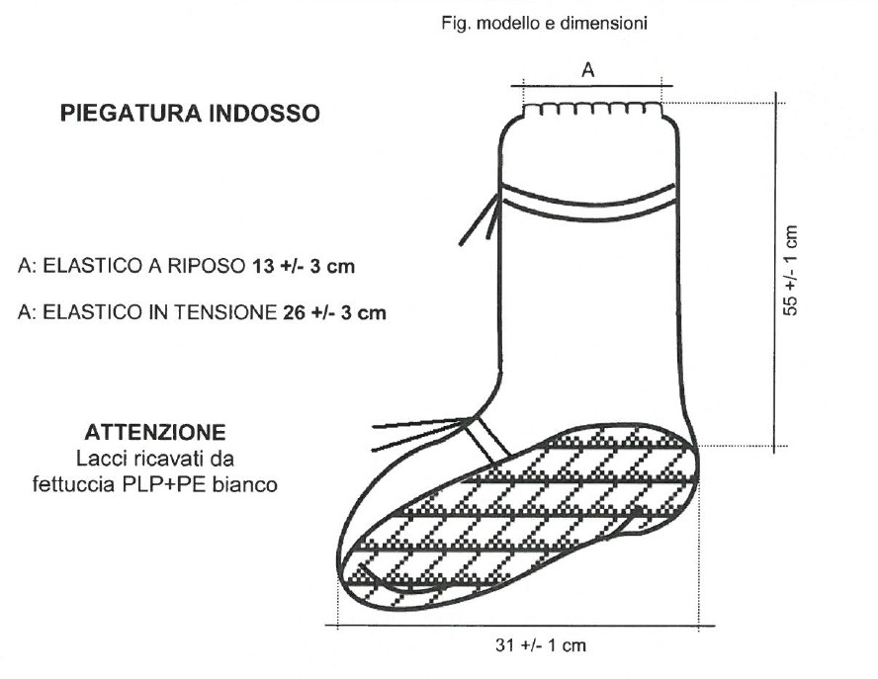
Description: Shoes with band + 4 laces + non-slip sole 31 cm long.

